Mongo DB Assignment

**Mongo DB Exercise in mongo shell**

Connect to a running mongo instance, use a database named **mongo_practice**.

Document all your queries in a java script file to use as a reference.

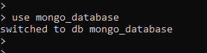

To create a collection



**Insert Documents**

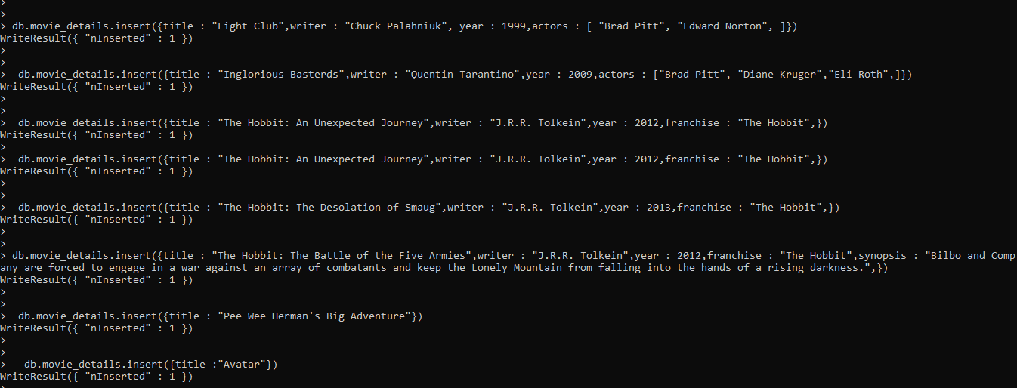

**Query / Find Documents**

1.Get all documents

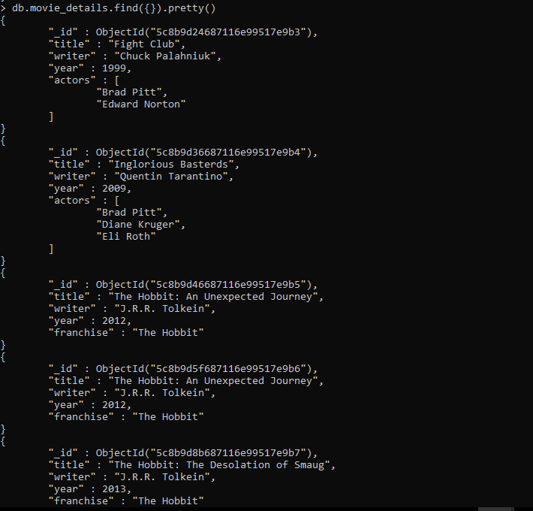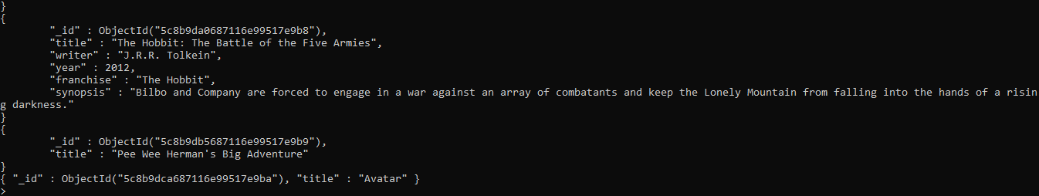2.Get all documents with writer set to "Quentin Tarantino" 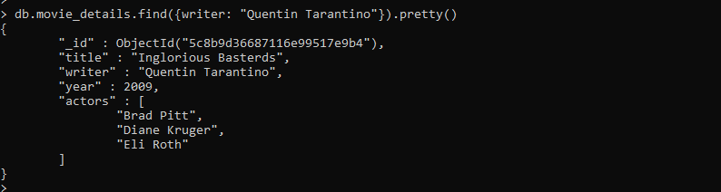

3.Get all documents where actors include "Brad Pitt"

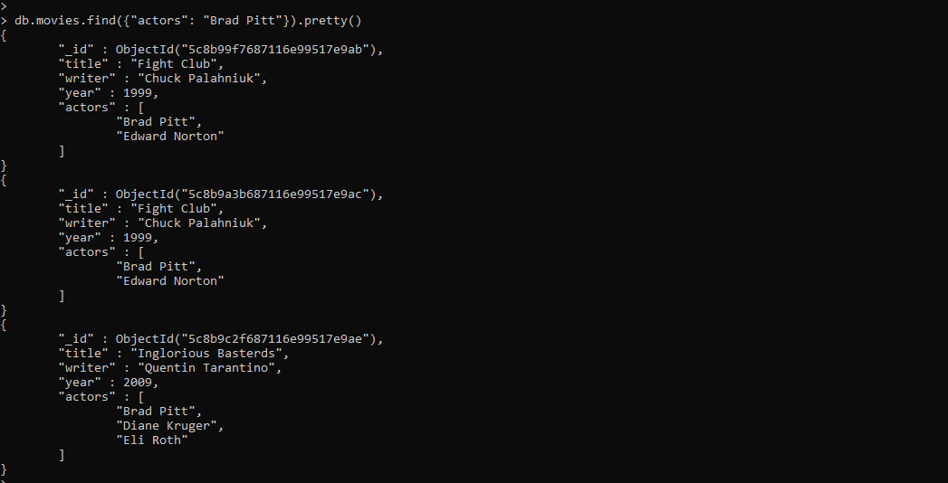

4.Get all documents with franchise set to "The Hobbit"

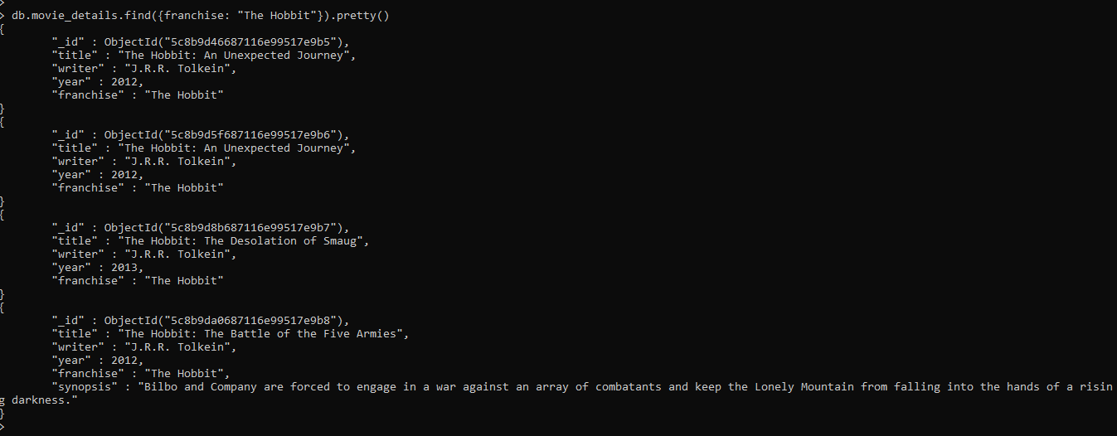

5.Get all movies released in the 90s

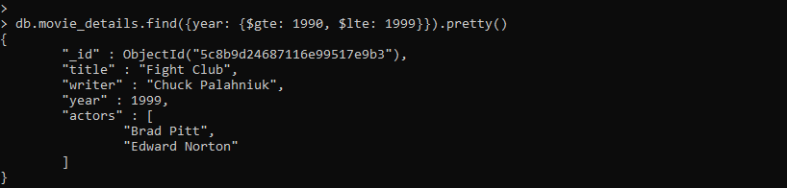

6.Get all movies released before the year 2000 or after 2010

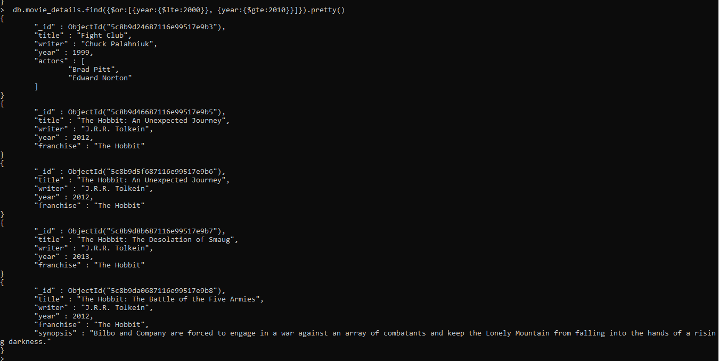

**Update Documents**

1. Add a synopsis to "The Hobbit: An Unexpected Journey" : "A reluctant hobbit, Bilbo Baggins, sets out to the Lonely Mountain with a spirited group of dwarves to reclaim their mountain home - and the gold within it - from the dragon Smaug."

2. Add a synopsis to "The Hobbit: The Desolation of Smaug" : "The dwarves, along with Bilbo Baggins and Gandalf the Grey, continue their quest to reclaim Erebor, their homeland, from Smaug. Bilbo Baggins is in possession of a mysterious and magical ring."

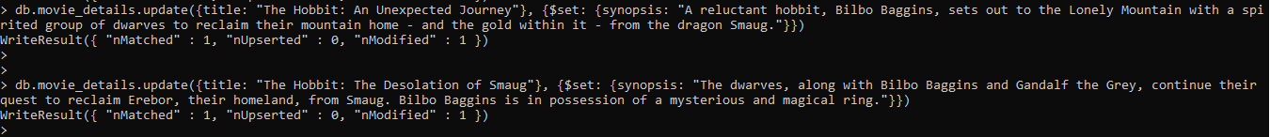

3. Add an actor named "Samuel L. Jackson" to the movie "Pulp Fiction"



**Text Search**

1. Find all movies that have a synopsis that contains the word "Bilbo"

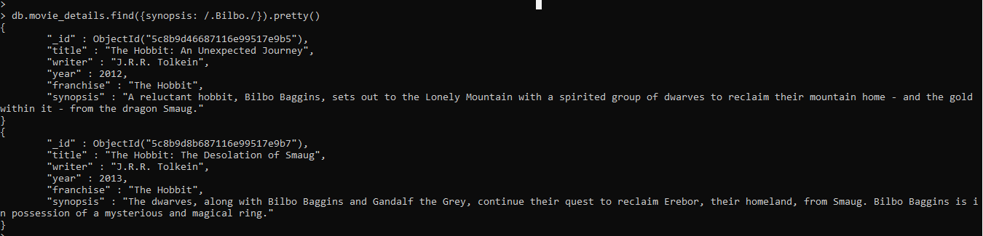

2. Find all movies that have a synopsis that contains the word "Gandalf"

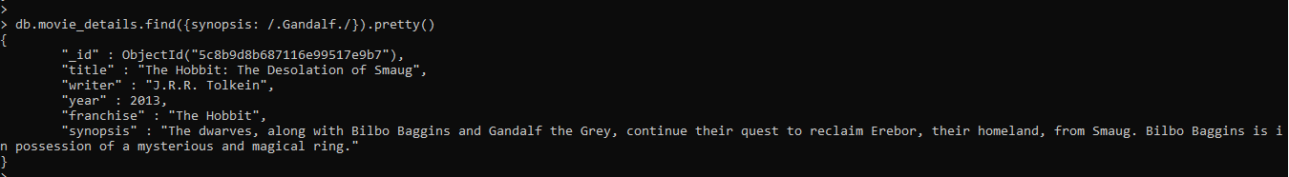

3. Find all movies that have a synopsis that contains the word "Bilbo" and not the word "Gandalf"

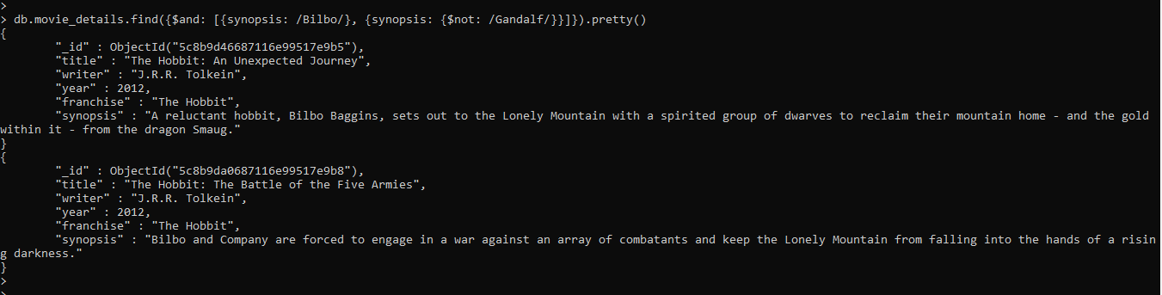

4. Find all movies that have a synopsis that contains the word "dwarves" or "hobbit"

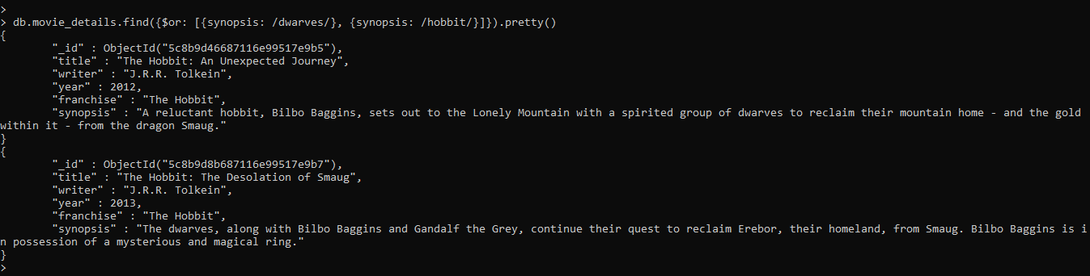

**Delete Documents**

1. Delete the movie "Pee Wee Herman's Big Adventure"



2. Delete the movie "Avatar"



**Querying related collections**

Create users collection and insert following values 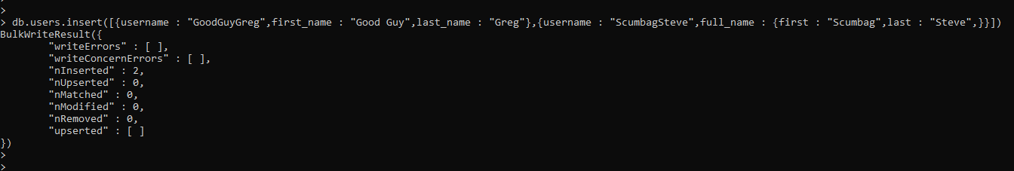

1. Find all users

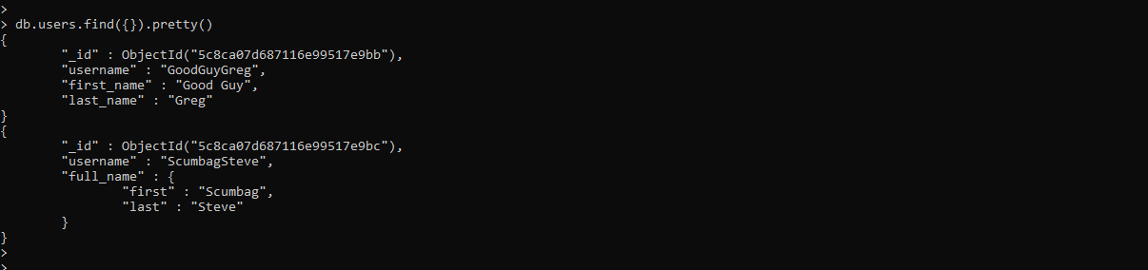

Create posts collection and insert following values

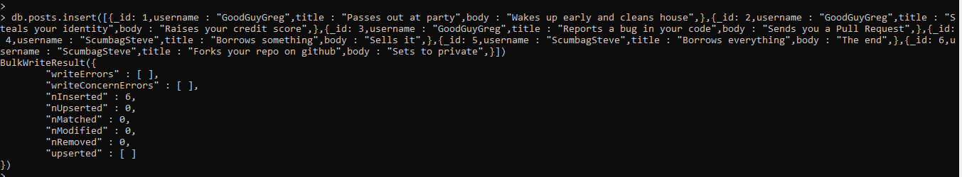

2. Find all posts

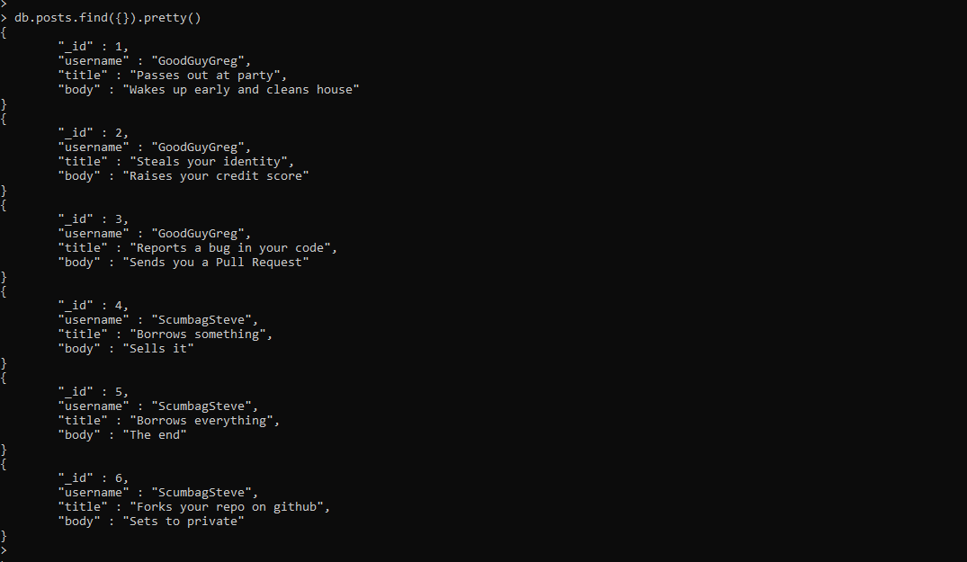

3. Find all posts that was authored by "GoodGuyGreg"

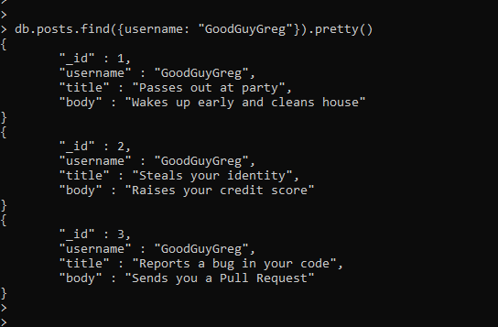

4. Find all posts that was authored by "ScumbagSteve"

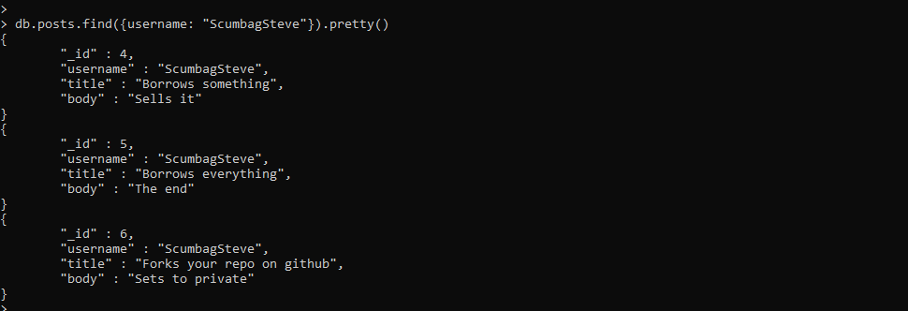

Create comments collection

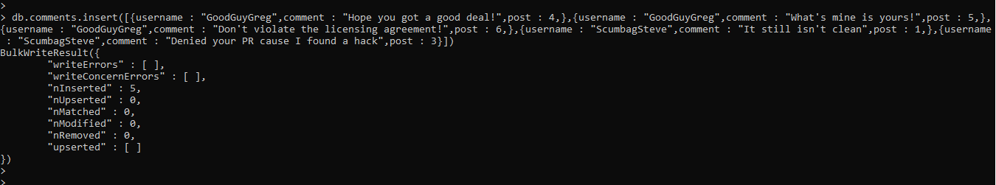

5. Find all comments

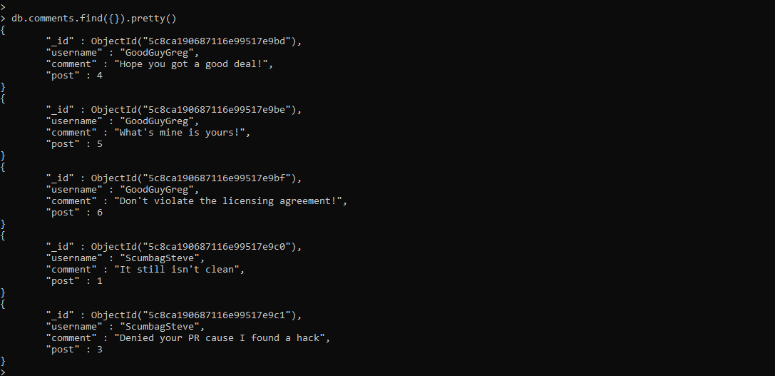

6. Find all comments that was authored by "GoodGuyGreg"

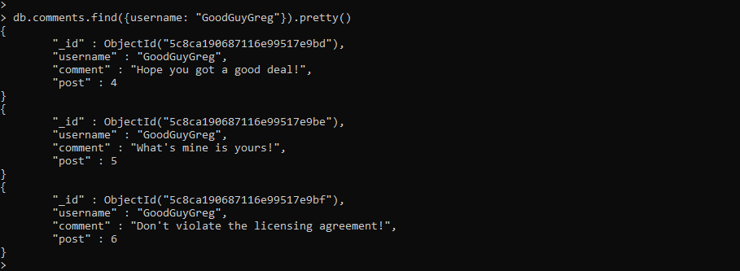

7. Find all comments that was authored by "ScumbagSteve"

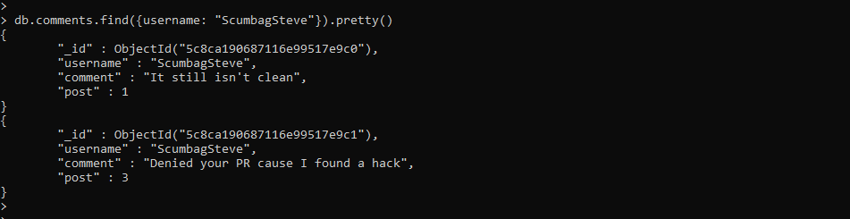

8. Find all comments belonging to the post "Reports a bug in your code"

